***Android App Development Test 4-1-2019***

Q no.1 **Row-1** Create Login application. On successful login, open browser with any URL.

Q no.2 **Row-2** Create an application that will pass some number to the next screen, and on the next screen that number of items should be display in the list.

Q no.3 **Row-3** a. Create spinner with strings taken from resource folder (res >> value folder).

b. On changing spinner value, change image.

Q no.4 **Row-1** Create an application that will display toast (Message) on specific interval of time.

Q no.5 **Row-2** Create “Android Studio Training” application. That will display “Android Studio Training” in the middle of the screen in the red color with white background using relative layout.

Q no.6 **Row-3**

Create application with login module. (Check username and password)

On successful login, go to next screen. And on failing login, alert user using Toast.

Also pass username to next screen.

Q no.7 **Row-2**

Create Application that send data and data show in fragment.

Q no.8 **Row-1**

Create a login App that save related data in key-Value Pair and send to next Screen that Show data.

Q no.9 **Compulsory for all**

Create a Custom list View like

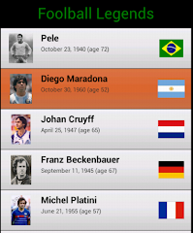

Images are available below.

Q no.10 **Row-3**

Create an Application that pass data from Fragment to Fragment.



